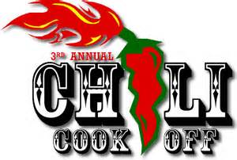

OFFICIAL 2018 CHILI COOK-OFF ENTRY FORM
ALL PROCEEDS BENEFIT NAMPA TROOP 112
Friday March 2, 2018

ENTRY TYPE INDIVIDUAL BUSINESS
TEAM NAME____________________________________________________________________________
CONTACT_________________________ PHONE________________E-MAIL_______________________
ALTERNATE CONTACT___________________ PHONE________________ E-MAIL_______________________

REGISTRATION DEADLINE FEBRUARY 1, 2018
INDIVIDUAL $20.00 ($25.00 AFTER February 1, 2018)
Individual registrant (2 free tickets) $20.00 Additional tickets ___________ x $10.00 = $__________

BUSINESS $100.00 ($125.00 AFTER February 1, 2018)
Business Registrant (includes 5 tickets) $100.00 Additional tickets ___________ x $10.00 = $___________

PLEASE CIRCLE ENTRY CATEGORY:

MILD SPICY WILD

1ST 2ND and 3RD PLACE Trophies will be awarded for EACH CATEGORY: MILD, SPICY, and WILD

THERE WILL ALSO BE A 1ST PLACE IN A PEOPLE’S CHOICE AWARD

FOR A COMPLETE LIST OF RULES VIST OUR WEBSITE AT WWW.TROOP112NAMPA.ORG
or contact Michelle Schafer @ 208-466-5584
Mail payments to Boy Scout Troop 112, 601 16th Ave S. Nampa ID 83651

If making CREDIT CARD PAYMENT:
Call Julie at 208-409-4851
Name:___________________________ Total entry fee with additional tickets $______________________________
Address ___________________________________________City_________________________ State____________
Visa MC Discover AMEX (additional 2.75% transaction fee will be applied)
Credit Card Number_____________________________________ Exp. Date____________ CVC________________
Signature Authorizing Payment______________________________________________________________________
Thank you for supporting the young men of Troop112

